PROJECT PLANNING PHASE
EV Market Analysis Dashboard
Product Backlog, Sprint Planning, User Stories, Story Points, Project Tracker, Velocity and Burndown Chart

1. Project Overview
The project will build an interactive EV Market Analysis Dashboard using the supplied ev_market_train dataset. The workbook contains 200,000 records and 37 columns. The dataset includes vehicle/model details, manufacturer, model year, country, market region, vehicle category, battery and performance specifications, price, safety/customer ratings, CO₂ savings, and annual sales. The dashboard will help users compare EV market patterns through KPIs, charts, filters, and tooltips.

Dataset Snapshot
Item | Details
Dataset file | ev_market_train.csv(1).xlsx
Rows / columns | 200,000 rows / 37 columns
Primary measures | annual_sales_units, range_km, price_usd, battery_capacity_kwh, customer_rating, co2_saved_tons_per_year
Main dimensions | manufacturer, category, battery_type, manufacturing_country, market_region, model_year, drivetrain, recommended_use_case
Proposed tool | Tableau Public; spreadsheet for source data inspection; optional Python/Pandas for data quality checks

2. Project Objective and Scope
Objective: create a clear, interactive dashboard that summarizes and compares EV sales, vehicle categories, battery technologies, range, pricing, ratings, manufacturing countries, and model years.
In scope: inspect and clean the supplied data; define consistent measures; create KPI cards and visualizations; add interactive filters/tooltips; validate totals and labels; publish or present the dashboard.
Out of scope: forecasting future sales, causal claims, live data feeds, and external data integration. Findings will describe the supplied dataset only.

3. Product Backlog and Sprint Planning (4 Marks)
Priority: High = required for a working submission; Medium = improves usability; Low = optional polish. Story points are estimates, not hours.
Sprint | Functional Requirement (Epic) | User Story Number | User Story / Task | Story Points | Priority | Team Members
Sprint-1 | Data Understanding & Quality | USN-1 | As a project team, we can inspect the dataset schema and confirm field meanings and data types. | 3 | High | Project team
Sprint-1 | Data Understanding & Quality | USN-2 | As a user, I can rely on key fields being checked for missing values, duplicates, invalid ranges, and inconsistent categories. | 5 | High | Data analyst
Sprint-1 | Data Understanding & Quality | USN-3 | As a reviewer, I can see a documented list of data-quality decisions and limitations. | 2 | Medium | Data analyst
Sprint-1 | KPI Design | USN-4 | As a user, I can see total recorded annual sales, average range, average price, and average customer rating at a glance. | 3 | High | Dashboard developer
Sprint-2 | Sales Analysis | USN-5 | As a user, I can compare recorded annual sales by manufacturer. | 3 | High | Dashboard developer
Sprint-2 | Category & Battery Analysis | USN-6 | As a user, I can explore sales by vehicle category and the distribution of battery types. | 3 | High | Dashboard developer
Sprint-2 | Range & Price Analysis | USN-7 | As a user, I can compare vehicle range and price and inspect average range across categories. | 3 | High | Dashboard developer
Sprint-2 | Ratings & Geography | USN-8 | As a user, I can explore customer ratings, manufacturing countries, and market regions. | 3 | Medium | Dashboard developer
Sprint-3 | Interactivity | USN-9 | As a user, I can filter views by manufacturer, category, battery type, country/region, and model year. | 5 | High | Dashboard developer
Sprint-3 | Interactivity | USN-10 | As a user, I can use tooltips, legends, and consistent labels to understand chart values. | 3 | Medium | Dashboard developer
Sprint-3 | Validation & Delivery | USN-11 | As a reviewer, I can verify chart totals against the source data and review a concise insights summary. | 3 | High | QA / reviewer
Sprint-3 | Validation & Delivery | USN-12 | As a presenter, I can publish or demonstrate the final dashboard with a clear title and usage notes. | 2 | Medium | Project team
Estimated backlog total: 38 story points. Sprint allocation: Sprint-1 = 13 points; Sprint-2 = 12 points; Sprint-3 = 13 points.

4. Sprint Schedule and Estimation
Sprint | Total Story Points | Duration | Sprint Start Date | Sprint End Date (Planned) | Story Points Completed (Planned) | Sprint Release Date (Actual)
Sprint-1 | 13 | 5 days | 19 Oct 2026 | 23 Oct 2026 | 13 | To be updated
Sprint-2 | 12 | 5 days | 26 Oct 2026 | 30 Oct 2026 | 12 | To be updated
Sprint-3 | 13 | 5 days | 02 Nov 2026 | 06 Nov 2026 | 13 | To be updated
Dates are a proposed plan and should be changed to match the team’s actual schedule. “Actual” release dates and completed points must be filled in after each sprint.

5. Project Tracker and Team Velocity (4 Marks)
Assumption for planning: a 10-day sprint with an estimated velocity of 20 story points. Average velocity per day = 20 ÷ 10 = 2 story points/day. The current backlog estimate is 38 points, so the team should plan capacity and adjust scope after tracking actual completion.
Track at each review: story points committed, story points completed, open tasks, blockers, data-quality issues, dashboard validation status, and release readiness.
Sprint | Committed Points | Completed Points | Blockers / Notes | Status
Sprint-1 | 13 | To update | Schema and data-quality checks | Planned
Sprint-2 | 12 | To update | Build charts and KPIs | Planned
Sprint-3 | 13 | To update | Filters, QA, insights, delivery | Planned

6. Burndown Chart
The chart below is an illustrative baseline for a 40-point, 10-day sprint, matching the example in the planning brief. Replace the planned line with daily remaining-work values once the actual sprint begins.
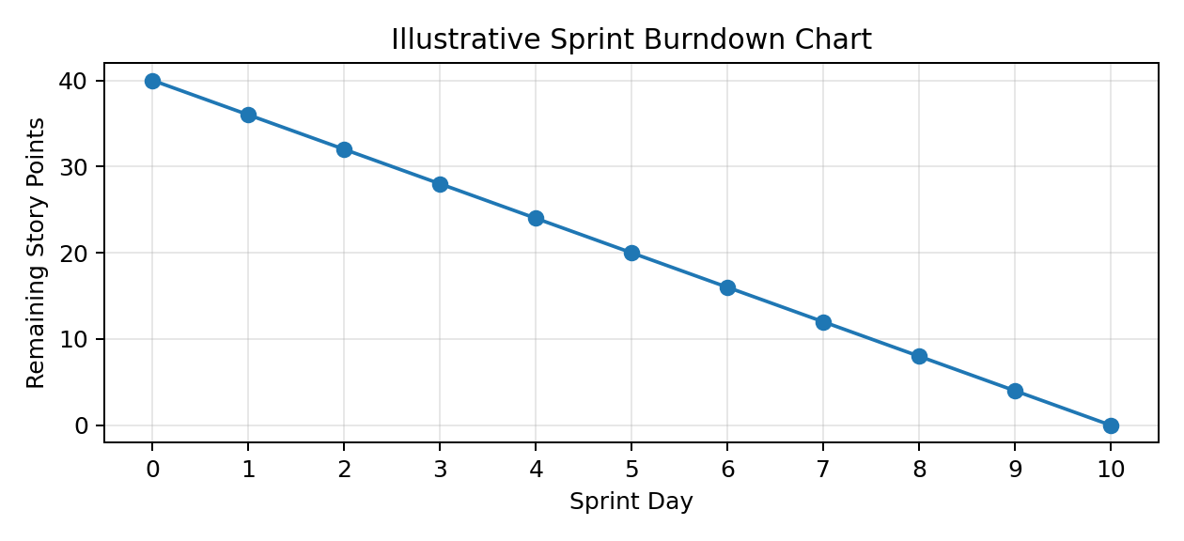
Daily tracking rule: remaining work = total committed story points − completed story points. Update at the end of each working day.

7. Acceptance Criteria
- Dataset fields and data types are reviewed; missing values, duplicates, and unusual values are documented.
- KPI values and chart aggregations are cross-checked against the source dataset.
- Dashboard includes manufacturer sales, category sales, battery distribution, range/price comparison, ratings, country/region, and model-year views.
- Filters and tooltips work consistently and do not mislead users about aggregation.
- The final dashboard has a clear title, readable labels, an insights summary, and a presentation-ready layout.
- If Tableau Public is used, the team understands that published workbooks are publicly viewable.

8. Risks and Mitigation
Risk | Mitigation
Missing or inconsistent values | Profile columns early; document any exclusions or treatment.
Large dataset slows authoring | Use extracts/aggregations where appropriate and keep worksheets focused.
Misleading comparisons across different vehicle types | Label measures clearly and allow category/region filters.
Time overrun | Prioritize core KPIs and required views before optional formatting.
Public sharing exposes the workbook/data | Review publishing settings and use Tableau Public only if public access is acceptable.

9. Deliverables
Cleaned/validated dataset notes; Tableau workbook/dashboard; KPI and visualization set; interactive filters/tooltips; short insights summary; project planning tracker; sprint burndown updates; final demonstration or presentation.
Note: This plan is based on the uploaded dataset structure (200,000 rows and 37 columns) and the provided Project Planning Template. Story points and dates are proposed estimates, not completed-work claims.

